Android Lab2：菜单UI设计报告
何衍宁12311512

菜单UI设计-version1.0（运行于Android Studio 2020.3.1）
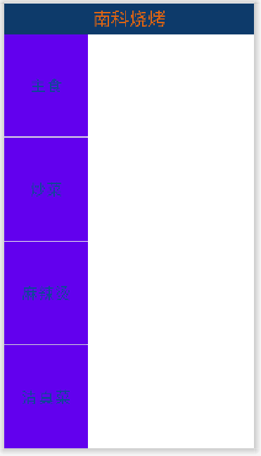
图1：菜单version1.0 UI界面
实现初步的布局及功能：
- 实现初步的布局。

Version1.0版本存在的问题：
- 颜色变化。
- Item仍未编程。
- 代码理解难度大。

优化过程
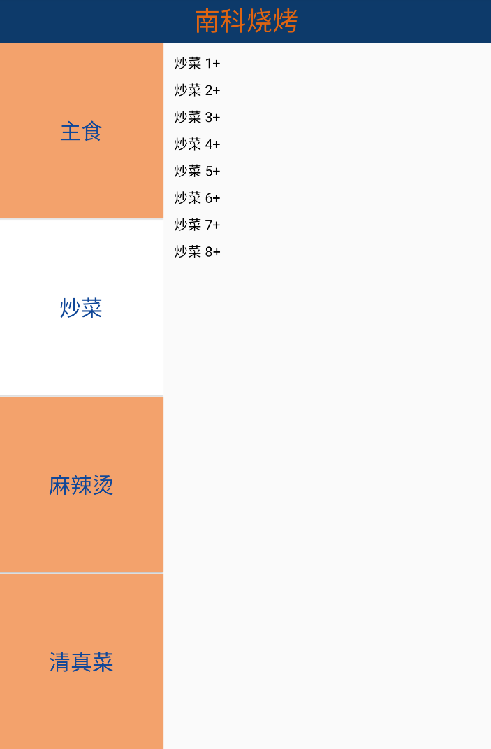
图2：Android Studio 2024.3.1显示界面
优化1：改用最新版的Android Studio，方便对代码进行debug。
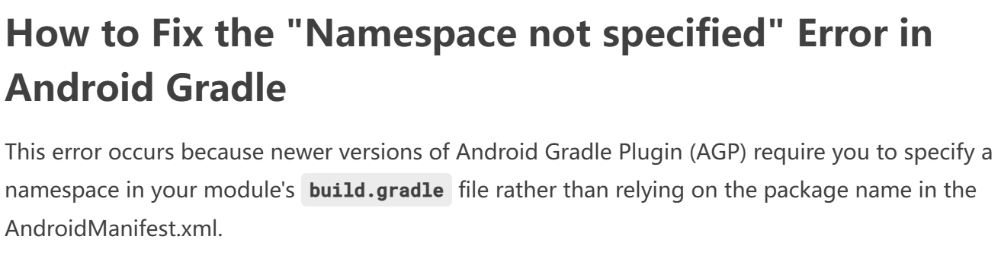
图3：Nexus 6 API30显示界面
优化2：最新版的Android Studio需要添加代码
1 | namespace 'com.example.week7'

菜单UI设计-version2.0（运行于Android Studio 2024.3.1）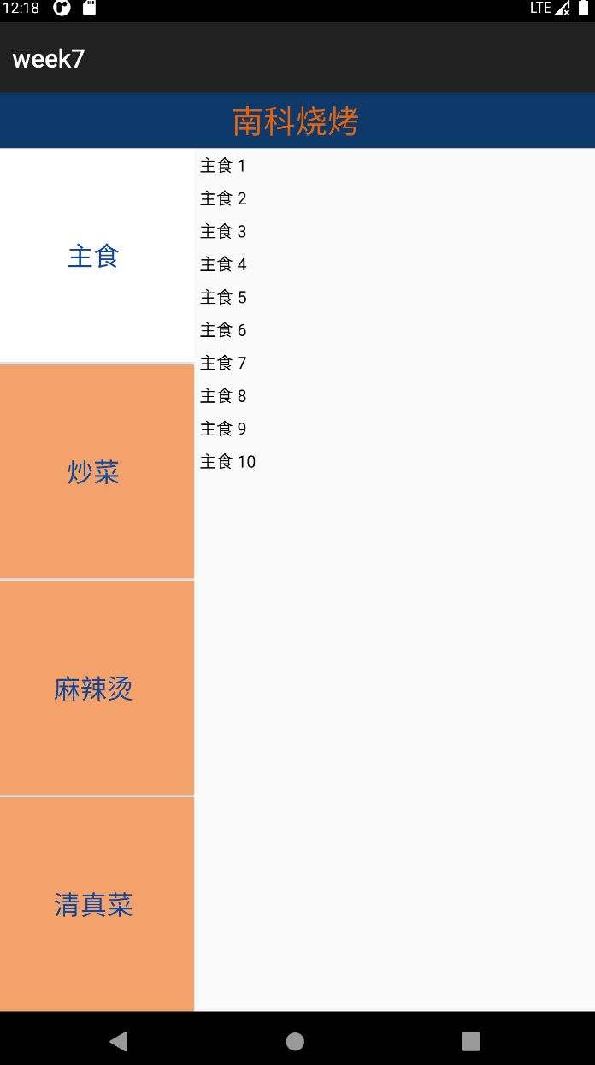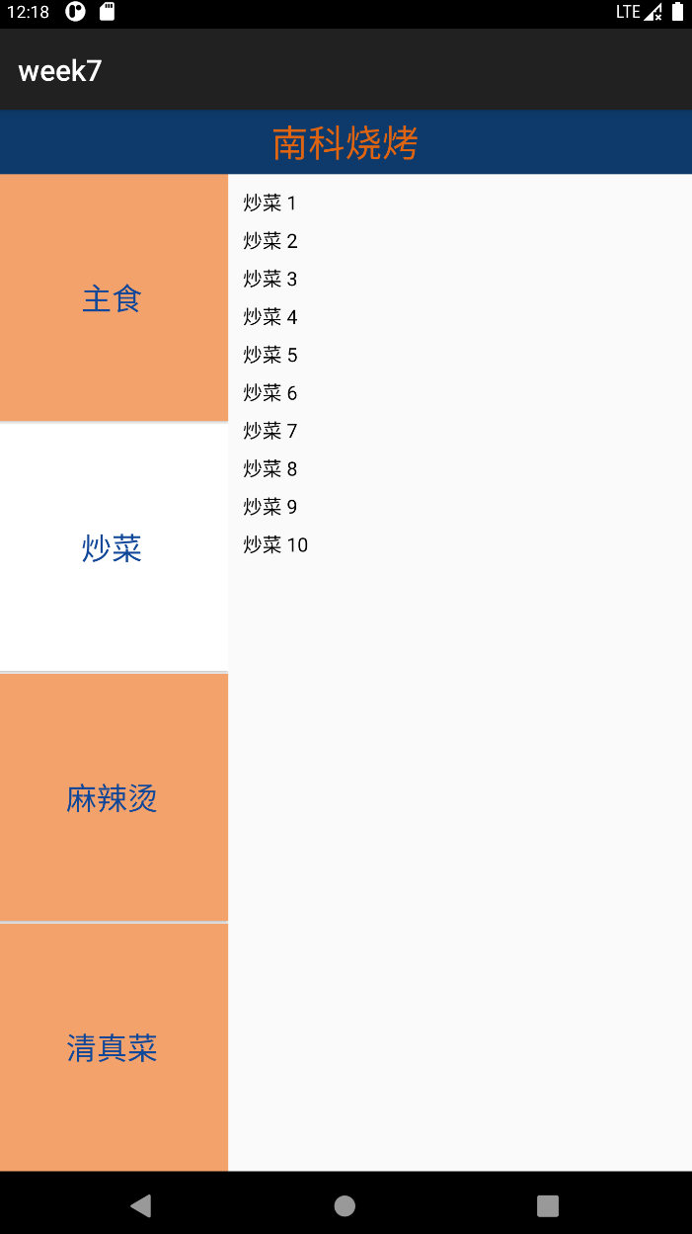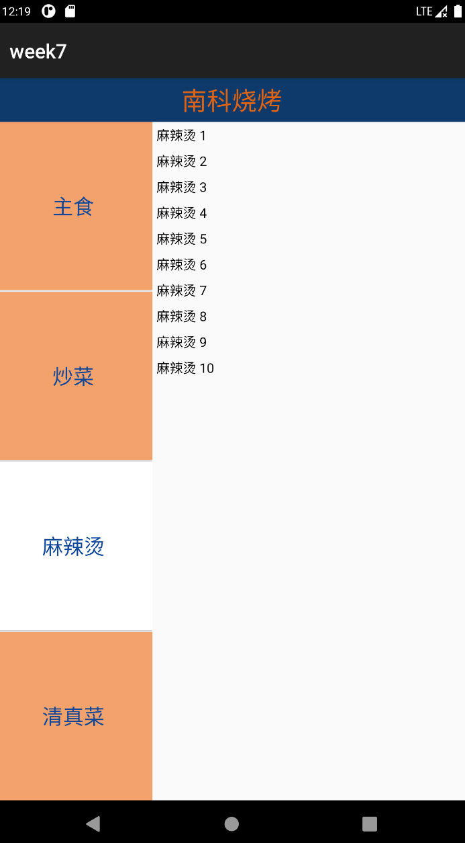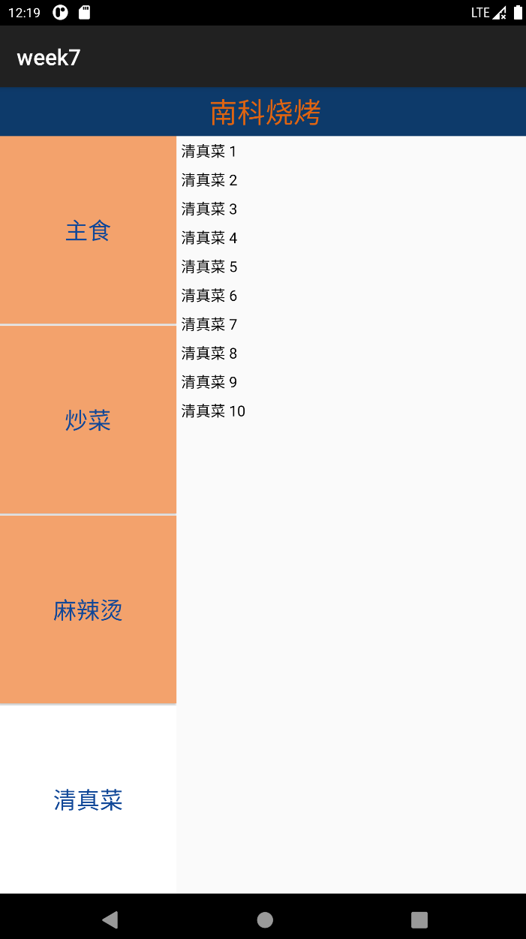

图4：菜单UI（最终版）

实现布局及功能：
- 选中的按钮呈现白色。
- 除选中的按钮外，其他按钮呈现橙色。
- 每个选项包含十项菜品。
- 实现基础的排版。
- 进一步美化。

附：项目完整代码
activity_main.xml
01  02  03  04  05  06  07  08  09  10  11  12  13  14  15  16  17  18  19  20  21  22  23  24  25  26  27  28  29  30  31  32  33  34  35  36  37  38  39  40  41  42  43  44  45  46  47  48  49  50  51  52  53  54  55  56  57  58  59  60  61  62  63  64  65  66  67  68  69  70  71  72  73  74  75  76  77  78 | <?xml version="1.0" encoding="utf-8"?>  <LinearLayout xmlns:android="http://schemas.android.com/apk/res/android"  xmlns:app="http://schemas.android.com/apk/res-auto"  xmlns:tools="http://schemas.android.com/tools"  android:layout_width="match_parent"  android:layout_height="match_parent"  tools:context=".MainActivity"  android:orientation="vertical">  <TextView  android:layout_width="match_parent"  android:layout_height="wrap_content"  android:text="南科烧烤"  android:gravity="center"  android:textColor="#DF6411"  android:textSize="30sp"  android:background="#0D3A6A"  android:padding="5dp"/>  <LinearLayout  android:id="@+id/ll_menu"  android:layout_width="match_parent"  android:layout_height="match_parent"  android:orientation="horizontal">  <LinearLayout  android:layout_width="0dp"  android:layout_height="match_parent"  android:layout_weight="1"  android:orientation="vertical">  <Button  android:id="@+id/btnzhushi"  android:layout_width="match_parent"  android:layout_height="0dp"  android:text="主食"  android:textSize="25sp"  android:textColor="#104798"  android:background="#F3A26C"  android:layout_weight="1"/>  <Button  android:id="@+id/btnchaocai"  android:layout_width="match_parent"  android:layout_height="0dp"  android:text="炒菜"  android:textSize="25sp"  android:textColor="#104798"  android:background="#F3A26C"  android:layout_weight="1"  android:layout_marginTop="2dp"/>  <Button  android:id="@+id/btnmalat"  android:layout_width="match_parent"  android:layout_height="0dp"  android:text="麻辣烫"  android:textSize="25sp"  android:textColor="#104798"  android:background="#F3A26C"  android:layout_weight="1"  android:layout_marginTop="2dp"/>  <Button  android:id="@+id/btnqingzhencai"  android:layout_width="match_parent"  android:layout_height="0dp"  android:text="清真菜"  android:textSize="25sp"  android:textColor="#104798"  android:background="#F3A26C"  android:layout_weight="1"  android:layout_marginTop="2dp"/>  </LinearLayout>  <LinearLayout  android:id="@+id/ll_detail"  android:layout_width="0dp"  android:layout_height="match_parent"  android:layout_weight="2"  android:orientation="horizontal">  </LinearLayout>  </LinearLayout>  </LinearLayout>

fragment_chaocai.xml
01  02  03  04  05  06  07  08  09  10  11  12  13 | <?xml version="1.0" encoding="utf-8"?>  <LinearLayout xmlns:android="http://schemas.android.com/apk/res/android"  android:layout_width="match_parent"  android:layout_height="match_parent"  android:orientation="vertical">  <androidx.recyclerview.widget.RecyclerView  android:id="@+id/recycler_view"  android:layout_width="match_parent"  android:layout_height="match_parent"  android:padding="6dp" />  </LinearLayout>

fragment_malat.xml
01  02  03  04  05  06  07  08  09  10  11  12  13  14  15  16  17 | <?xml version="1.0" encoding="utf-8"?>  <androidx.constraintlayout.widget.ConstraintLayout xmlns:android="http://schemas.android.com/apk/res/android"  xmlns:app="http://schemas.android.com/apk/res-auto"  xmlns:tools="http://schemas.android.com/tools"  android:layout_width="match_parent"  android:layout_height="match_parent"  tools:context=".malatFragment">  <androidx.recyclerview.widget.RecyclerView  android:id="@+id/recycler_view"  android:layout_width="match_parent"  android:layout_height="match_parent"  app:layout_constraintTop_toTopOf="parent"  app:layout_constraintBottom_toBottomOf="parent"  app:layout_constraintStart_toStartOf="parent"  app:layout_constraintEnd_toEndOf="parent" />  </androidx.constraintlayout.widget.ConstraintLayout>

fragment_qingzhencai.xml
01  02  03  04  05  06  07  08  09  10  11  12  13  14  15  16  17 | <?xml version="1.0" encoding="utf-8"?>  <androidx.constraintlayout.widget.ConstraintLayout xmlns:android="http://schemas.android.com/apk/res/android"  xmlns:app="http://schemas.android.com/apk/res-auto"  xmlns:tools="http://schemas.android.com/tools"  android:layout_width="match_parent"  android:layout_height="match_parent"  tools:context=".qingzhencaiFragment">  <androidx.recyclerview.widget.RecyclerView  android:id="@+id/recycler_view"  android:layout_width="match_parent"  android:layout_height="match_parent"  app:layout_constraintTop_toTopOf="parent"  app:layout_constraintBottom_toBottomOf="parent"  app:layout_constraintStart_toStartOf="parent"  app:layout_constraintEnd_toEndOf="parent" />  </androidx.constraintlayout.widget.ConstraintLayout>

fragment_zhushi.xml
01  02  03  04  05  06  07  08  09  10  11  12  13  14  15  16  17 | <?xml version="1.0" encoding="utf-8"?>  <androidx.constraintlayout.widget.ConstraintLayout xmlns:android="http://schemas.android.com/apk/res/android"  xmlns:app="http://schemas.android.com/apk/res-auto"  xmlns:tools="http://schemas.android.com/tools"  android:layout_width="match_parent"  android:layout_height="match_parent"  tools:context=".zhushiFragment">  <androidx.recyclerview.widget.RecyclerView  android:id="@+id/recycler_view"  android:layout_width="match_parent"  android:layout_height="match_parent"  app:layout_constraintTop_toTopOf="parent"  app:layout_constraintBottom_toBottomOf="parent"  app:layout_constraintStart_toStartOf="parent"  app:layout_constraintEnd_toEndOf="parent" />  </androidx.constraintlayout.widget.ConstraintLayout>

itemlayout.xml
01  02  03  04  05  06  07  08  09  10  11  12  13  14 | <?xml version="1.0" encoding="utf-8"?>  <LinearLayout xmlns:android="http://schemas.android.com/apk/res/android"  android:layout_width="match_parent"  android:layout_height="wrap_content"  android:orientation="vertical">  <TextView  android:id="@+id/item_text"  android:layout_width="wrap_content"  android:layout_height="wrap_content"  android:textColor="#000000"  android:textSize="16sp"  android:padding="4dp" />  </LinearLayout>

MainActivity
001  002  003  004  005  006  007  008  009  010  011  012  013  014  015  016  017  018  019  020  021  022  023  024  025  026  027  028  029  030  031  032  033  034  035  036  037  038  039  040  041  042  043  044  045  046  047  048  049  050  051  052  053  054  055  056  057  058  059  060  061  062  063  064  065  066  067  068  069  070  071  072  073  074  075  076  077  078  079  080  081  082  083  084  085  086  0878  089  090  091  092  093  094  095  096  097  098  099  100  101 | package com.example.week7;  import androidx.annotation.NonNull;  import androidx.appcompat.app.AppCompatActivity;  import androidx.recyclerview.widget.LinearLayoutManager;  import androidx.recyclerview.widget.RecyclerView;  import android.animation.ObjectAnimator;  import android.annotation.SuppressLint;  import android.content.ComponentName;  import android.content.Intent;  import android.content.ServiceConnection;  import android.graphics.Color;  import android.media.MediaPlayer;  import android.os.Bundle;  import android.os.Handler;  import android.os.HandlerThread;  import android.os.IBinder;  import android.os.Looper;  import android.os.Message;  import android.view.View;  import android.view.ViewGroup;  import android.view.animation.LinearInterpolator;  import android.widget.Button;  import android.widget.ImageView;  import android.widget.SeekBar;  import android.widget.TextView;  import java.util.Timer;  public class MainActivity extends AppCompatActivity{  private zhushiFragment zhushiFragment = new zhushiFragment();//声明Fragment  private chaocaiFragment chaocaiFragment = new chaocaiFragment();  private malatFragment malatFragment=new malatFragment();  private qingzhencaiFragment qingzhencaiFragment=new qingzhencaiFragment();  private Button btn_zhushi,btn_chaocai,btn_mlt,btn_qzc;  @SuppressLint("MissingInflatedId")  @Override  protected void onCreate(Bundle savedInstanceState) {  super.onCreate(savedInstanceState);  setContentView(R.layout.activity_main);  getSupportFragmentManager().beginTransaction().add(R.id.ll_detail,zhushiFragment).commitAllowingStateLoss();//绑定Fragment  btn_zhushi = findViewById(R.id.btnzhushi);  btn_chaocai = findViewById(R.id.btnchaocai);  btn_mlt= findViewById(R.id.btnmalat);  btn_qzc= findViewById(R.id.btnqingzhencai);  OnClick onClick = new OnClick();  btn_zhushi.setOnClickListener(onClick);  btn_chaocai.setOnClickListener(onClick);  btn_mlt. setOnClickListener(onClick);  btn_qzc.setOnClickListener(onClick);  btn_zhushi.performClick();//自动点击  }  private class OnClick implements View.OnClickListener{  @Override  public void onClick(View view) {  if(view.getId()==R.id.btnzhushi){  btn_zhushi.setBackgroundColor(getResources().getColor(R.color.white));  btn_chaocai.setBackgroundColor(getResources().getColor(R.color.oringin));  btn_mlt.setBackgroundColor(getResources().getColor(R.color.oringin));  btn_qzc. setBackgroundColor(getResources().getColor(R.color.oringin));  getSupportFragmentManager().beginTransaction().replace(R.id.ll_detail,zhushiFragment).commitAllowingStateLoss();  }  else if(view.getId()==R.id.btnchaocai){  btn_zhushi.setBackgroundColor(getResources().getColor(R.color.oringin));  btn_chaocai.setBackgroundColor(getResources().getColor(R.color.white));  btn_mlt.setBackgroundColor(getResources().getColor(R.color.oringin));  btn_qzc. setBackgroundColor(getResources().getColor(R.color.oringin));  getSupportFragmentManager().beginTransaction().replace(R.id.ll_detail,chaocaiFragment).commitAllowingStateLoss();  }  else if(view.getId()==R.id.btnmalat){  btn_zhushi.setBackgroundColor(getResources().getColor(R.color.oringin));  btn_chaocai.setBackgroundColor(getResources().getColor(R.color.oringin));  btn_mlt.setBackgroundColor(getResources().getColor(R.color.white));  btn_qzc. setBackgroundColor(getResources().getColor(R.color.oringin));  getSupportFragmentManager().beginTransaction().replace(R.id.ll_detail,malatFragment).commitAllowingStateLoss();  }  else if(view.getId()==R.id.btnqingzhencai){  btn_zhushi.setBackgroundColor(getResources().getColor(R.color.oringin));  btn_chaocai.setBackgroundColor(getResources().getColor(R.color.oringin));  btn_mlt.setBackgroundColor(getResources().getColor(R.color.oringin));  btn_qzc. setBackgroundColor(getResources().getColor(R.color.white));  getSupportFragmentManager().beginTransaction().replace(R.id.ll_detail,qingzhencaiFragment).commitAllowingStateLoss();  }  }  }  }

chaocaiFragment
01  02  03  04  05  06  07  08  09  10  11  12  13  14  15  16  17  18  19  20  21  22  23  24  25  26  27  28  29  30  31  32  33  34  35  36  37  38  39  40 | package com.example.week7;  import androidx.fragment.app.Fragment;  import androidx.recyclerview.widget.LinearLayoutManager;  import androidx.recyclerview.widget.RecyclerView;  import android.os.Bundle;  import android.view.LayoutInflater;  import android.view.View;  import android.view.ViewGroup;  import java.util.ArrayList;  import java.util.List;  public class chaocaiFragment extends Fragment {  private RecyclerView recyclerView;  private ItemAdapter itemAdapter;  @Override  public View onCreateView(LayoutInflater inflater, ViewGroup container,  Bundle savedInstanceState) {  View view = inflater.inflate(R.layout.fragment_chaocai, container, false);  recyclerView = view.findViewById(R.id.recycler_view);  recyclerView.setLayoutManager(new LinearLayoutManager(getContext()));  List<String> itemList = new ArrayList<>();  for (int i = 1; i <= 10; i++) {  itemList.add("炒菜 " + i );  }  itemAdapter = new ItemAdapter(getContext(), itemList);  recyclerView.setAdapter(itemAdapter);  return view;  }  }

malatFragment
01  02  03  04  05  06  07  08  09  10  11  12  13  14  15  16  17  18  19  20  21  22  23  24  25  26  27  28  29  30  31  32  33  34  35  36  37  38  39 | package com.example.week7;  import androidx.fragment.app.Fragment;  import androidx.recyclerview.widget.LinearLayoutManager;  import androidx.recyclerview.widget.RecyclerView;  import android.os.Bundle;  import android.view.LayoutInflater;  import android.view.View;  import android.view.ViewGroup;  import java.util.ArrayList;  import java.util.List;  public class malatFragment extends Fragment {  private RecyclerView recyclerView;  private ItemAdapter itemAdapter;  @Override  public View onCreateView(LayoutInflater inflater, ViewGroup container, Bundle savedInstanceState) {  View view = inflater.inflate(R.layout.fragment_malat, container, false);  recyclerView = view.findViewById(R.id.recycler_view);  recyclerView.setLayoutManager(new LinearLayoutManager(getContext()));  List<String> itemList = new ArrayList<>();  for (int i = 1; i <= 10; i++) {  itemList.add("麻辣烫 " + i);  }  itemAdapter = new ItemAdapter(getContext(), itemList);  recyclerView.setAdapter(itemAdapter);  return view;  }  }

qingzhencaiFragment
01  02  03  04  05  06  07  08  09  10  11  12  13  14  15  16  17  18  19  20  21  22  23  24  25  26  27  28  29  30  31  32  33  34  35  36  37  38  39 | package com.example.week7;  import androidx.fragment.app.Fragment;  import androidx.recyclerview.widget.LinearLayoutManager;  import androidx.recyclerview.widget.RecyclerView;  import android.os.Bundle;  import android.view.LayoutInflater;  import android.view.View;  import android.view.ViewGroup;  import java.util.ArrayList;  import java.util.List;  public class qingzhencaiFragment extends Fragment {  private RecyclerView recyclerView;  private ItemAdapter itemAdapter;  @Override  public View onCreateView(LayoutInflater inflater, ViewGroup container, Bundle savedInstanceState) {  View view = inflater.inflate(R.layout.fragment_qingzhencai, container, false);  recyclerView = view.findViewById(R.id.recycler_view);  recyclerView.setLayoutManager(new LinearLayoutManager(getContext()));  List<String> itemList = new ArrayList<>();  for (int i = 1; i <= 10; i++) {  itemList.add("清真菜 " + i);  }  itemAdapter = new ItemAdapter(getContext(), itemList);  recyclerView.setAdapter(itemAdapter);  return view;  }  }

zhushiFragment
01  02  03  04  05  06  07  08  09  10  11  12  13  14  15  16  17  18  19  20  21  22  23  24  25  26  27  28  29  30  31  32  33  34  35  36  37  38  39 | package com.example.week7;  import androidx.fragment.app.Fragment;  import androidx.recyclerview.widget.LinearLayoutManager;  import androidx.recyclerview.widget.RecyclerView;  import android.os.Bundle;  import android.view.LayoutInflater;  import android.view.View;  import android.view.ViewGroup;  import java.util.ArrayList;  import java.util.List;  public class zhushiFragment extends Fragment {  private RecyclerView recyclerView;  private ItemAdapter itemAdapter;  @Override  public View onCreateView(LayoutInflater inflater, ViewGroup container,  Bundle savedInstanceState) {  View view = inflater.inflate(R.layout.fragment_zhushi, container, false);  recyclerView = view.findViewById(R.id.recycler_view);  recyclerView.setLayoutManager(new LinearLayoutManager(getContext()));  List<String> itemList = new ArrayList<>();  for (int i = 1; i <= 10; i++) {  itemList.add("主食 " + i );  }  itemAdapter = new ItemAdapter(getContext(), itemList);  recyclerView.setAdapter(itemAdapter);  return view;  }  }

ItemAdapter
01  02  03  04  05  06  07  08  09  10  11  12  13  14  15  16  17  18  19  20  21  22  23  24  25  26  27  28  29  30  31  32  33  34  35  36  37  38  39  40  41  42  43  44  45  46  47  48 | package com.example.week7;  import android.content.Context;  import android.view.LayoutInflater;  import android.view.View;  import android.view.ViewGroup;  import android.widget.TextView;  import androidx.annotation.NonNull;  import androidx.recyclerview.widget.RecyclerView;  import java.util.List;  public class ItemAdapter extends RecyclerView.Adapter<ItemAdapter.ItemViewHolder> {  private List<String> dataList;  private Context context;  public ItemAdapter(Context context, List<String> dataList) {  this.context = context;  this.dataList = dataList;  }  @NonNull  @Override  public ItemViewHolder onCreateViewHolder(@NonNull ViewGroup parent, int viewType) {  View view = LayoutInflater.from(context).inflate(R.layout.itemlayout, parent, false);  return new ItemViewHolder(view);  }  @Override  public void onBindViewHolder(@NonNull ItemViewHolder holder, int position) {  holder.itemText.setText(dataList.get(position));  }  @Override  public int getItemCount() {  return dataList.size();  }  public static class ItemViewHolder extends RecyclerView.ViewHolder {  TextView itemText;  public ItemViewHolder(@NonNull View itemView) {  super(itemView);  itemText = itemView.findViewById(R.id.item_text);  }  }  }

colors.xml
01  02  03  04  05  06  07  08  09  10  11  12  13  14  15  16 | <?xml version="1.0" encoding="utf-8"?>  <resources>  <color name="purple_200">#FFBB86FC</color>  <color name="purple_500">#FF6200EE</color>  <color name="purple_700">#FF3700B3</color>  <color name="teal_200">#FF03DAC5</color>  <color name="teal_700">#FF018786</color>  <color name="black">#FF000000</color>  <color name="white">#FFFFFFFF</color>  <color name="light_blue_600">#FF039BE5</color>  <color name="light_blue_900">#FF01579B</color>  <color name="light_blue_A200">#FF40C4FF</color>  <color name="light_blue_A400">#FF00B0FF</color>  <color name="black_overlay">#66000000</color>  <color name="oringin">#F3A26C</color>  </resources>

Build.gradle
01  02  03  04  05  06  07  08  09  10  11  12  13  14  15  16  17  18  19  20  21  22  23  24  25  26  27  28  29  30  31  32  33  34  35  36  37  38  39 | plugins {  id 'com.android.library'  }  android {  namespace 'com.example.week7'  compileSdk 34  defaultConfig {  minSdk 21  targetSdk 34  versionCode 1  versionName "1.0"  testInstrumentationRunner "androidx.test.runner.AndroidJUnitRunner"  consumerProguardFiles "consumer-rules.pro"  }  buildTypes {  release {  minifyEnabled false  proguardFiles getDefaultProguardFile('proguard-android-optimize.txt'), 'proguard-rules.pro'  }  }  compileOptions {  sourceCompatibility JavaVersion.VERSION_1_8  targetCompatibility JavaVersion.VERSION_1_8  }  }  dependencies {  implementation 'androidx.appcompat:appcompat:1.2.0'  implementation 'com.google.android.material:material:1.3.0'  testImplementation 'junit:junit:4.+'  androidTestImplementation 'androidx.test.ext:junit:1.1.2'  androidTestImplementation 'androidx.test.espresso:espresso-core:3.3.0'  }

